

**Paragon International University**

**Department of Computer Science**

**Simon Game**

**Course: CS 126**

**Instructor: Flordeliza Poncio Payagan**

**Student’s Name: Bunnarith Heang**

**CS Portfolio Project**

**“Simon Game”**

The game called, **“Simon Game”.** It is a game that require the player to focus and remember the colors and number that flashes. So, each round will have colors flashes and at the end of the round the player has to select the colors in the same order that it flashes.

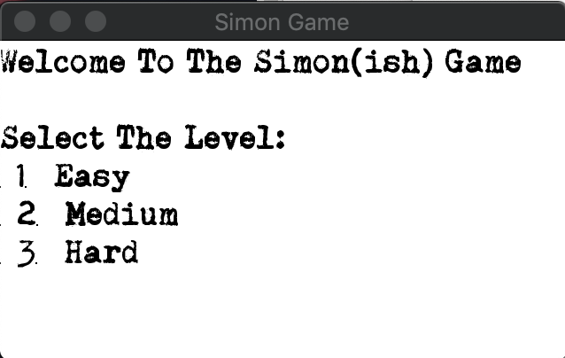

Figure : Menu Screen

So, at the start of the game, the player will be asked to select the difficulty level according to their preferences. The only differences between each level is the time between each flash, the easy level will give the player a lot more time to remember while the hard level will cut the time shorter between each flash. Easy = 0.4second, Medium = 0.30second, hard = 0.25second.

After the player has finally select the difficulty level, the player will be greeted with a colorful-looking window, which will be used to as the main game space.

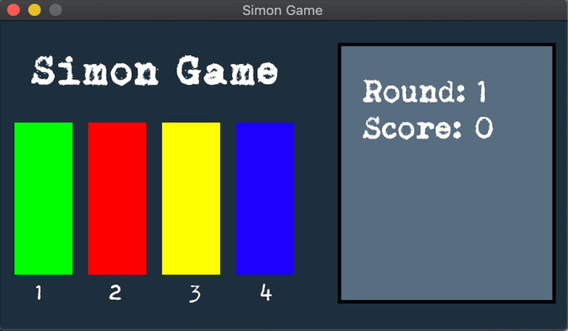

Figure : Game Screen

And after a few seconds, the first round will start and the colors will start flashing, the first round will start will 3 colors, the maximum number of flashes is 5 flashes per round.

After the 3 color flashes of the first round, the player will have to type in the number of the colors that have been flashed in the same order. If the player manages to choose the correct colors, the player will continue to round 2, and if they manage to win round 2, they will continue to round 3, and so on. However, if at any round, the player fails to choose the correct color, they lose the game.

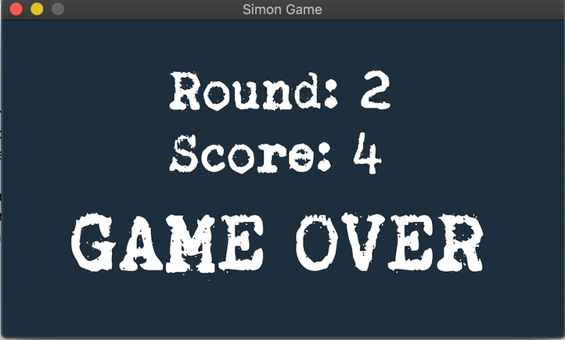

Figure : Game Over Screen

Talking about the code, I’m utilizing the SFML Library.

The code consists of 4 functions:

* Main function which handles conditions in the game.
* Second one handles the definitions of the shapes, text and colors of the game screen.
* Third function plays the sounds of each color accordingly.
* The final function generates random numbers from 1 to 4.